МИНИСТЕРСТВО ОБРАЗОВАНИЯ И НАУКИ РОССИЙСКОЙ ФЕДЕРАЦИИ

ФЕДЕРАЛЬНОЕ государственное БЮДЖЕТНОЕ
образовательное учреждение
высшего образования
«НОВОСИБИРСКИЙ ГОСУДАРСТВЕННЫЙ ТЕХНИЧЕСКИЙ УНИВЕРСИТЕТ»
__________________________________________________________________
Кафедра автоматизированных систем управления



ОТЧЁТ
по расчетно-графическому заданию
«Игра «Морской бой» (противник программа на компьютере в локальной сети)»
по дисциплине: «Технологии и методы программирования»

Выполнил: Проверил:
студент группы АВТ-113
Войнова А.М. Попов Е. А.

Новосибирск 2023
1. Демонстрация работы программы
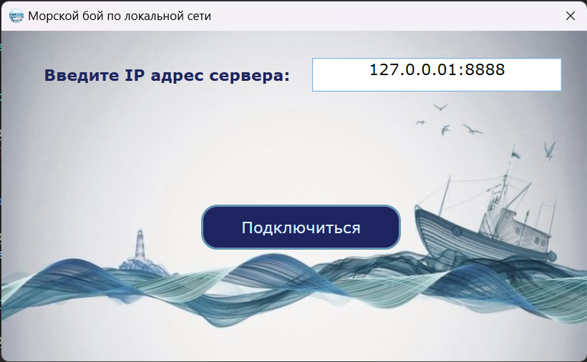
Рис. 1. Окно подключения к серверу

Рис. 2. Создание новой игры
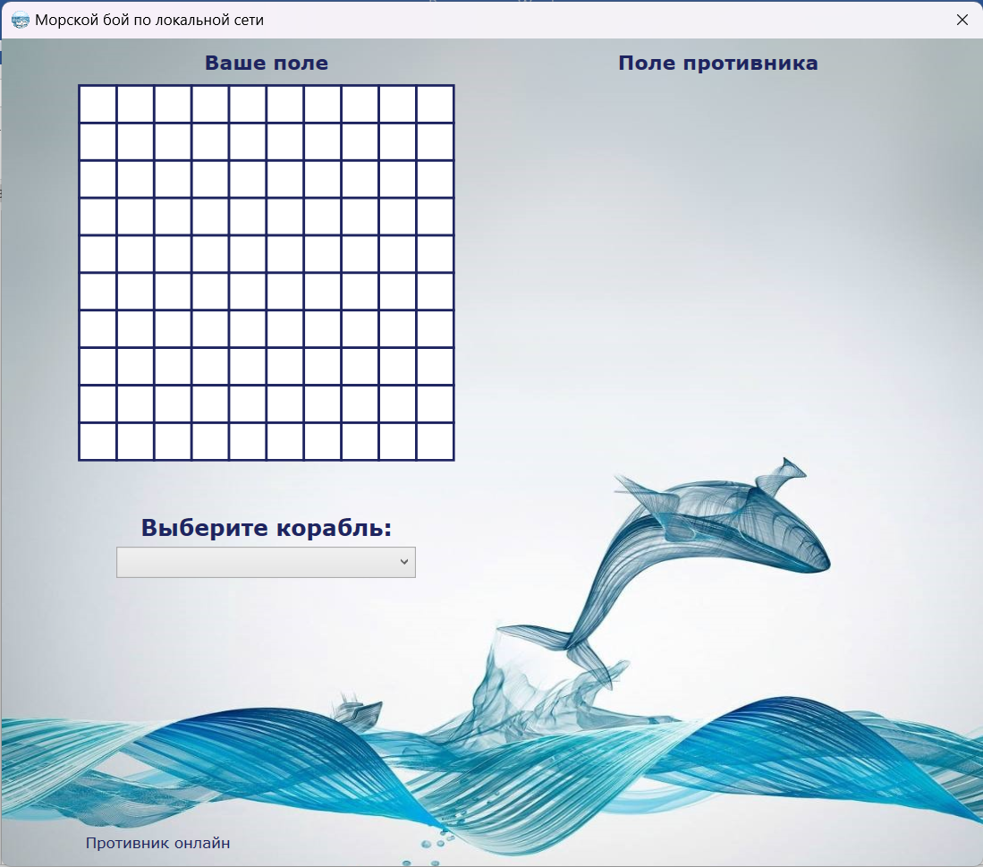
Рис. 3. Окно для расположения кораблей
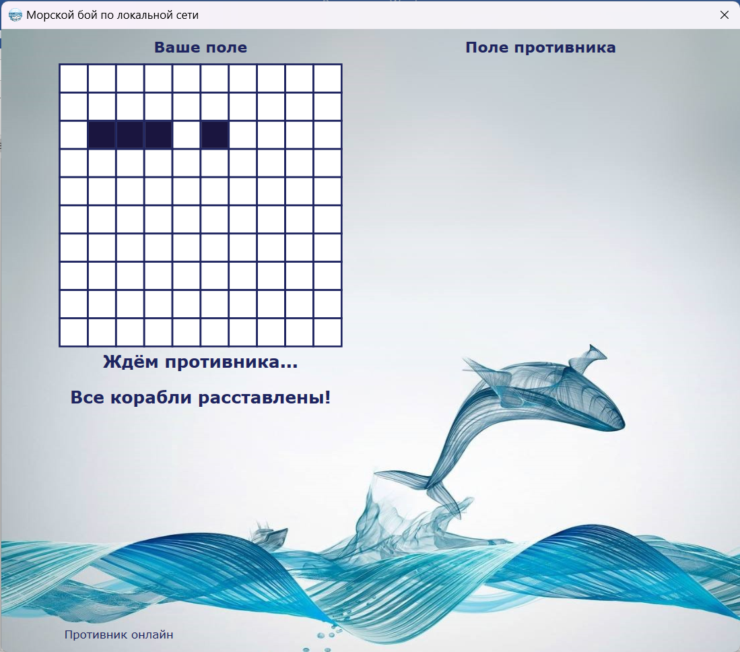
Рис. 4. Окно после расположения кораблей
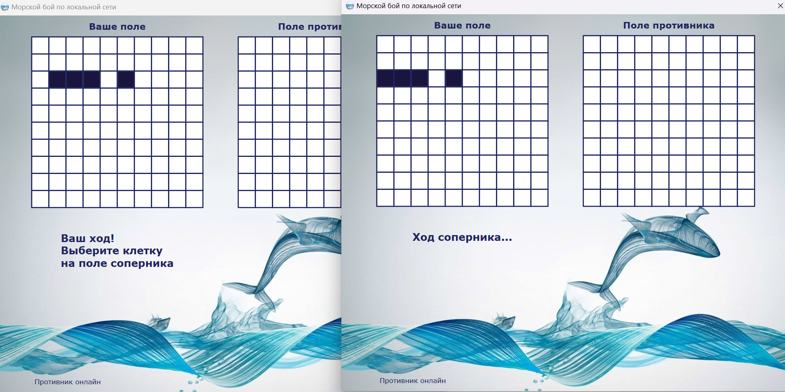
Рис. 5. Старт игры
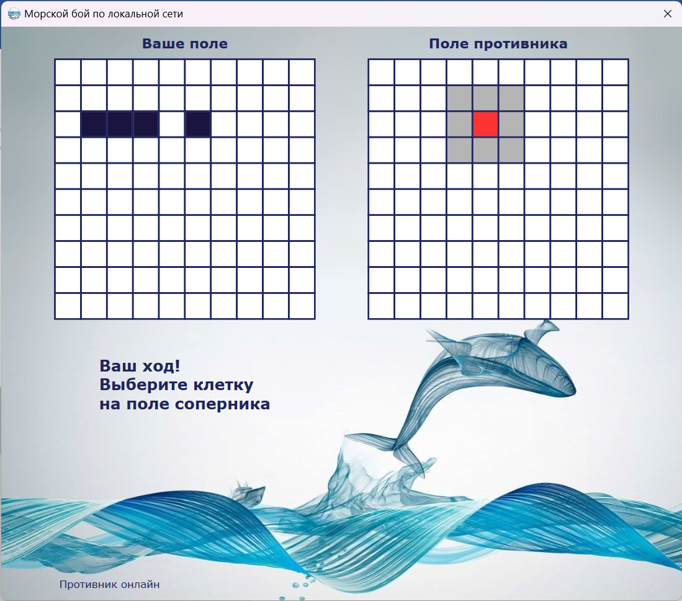
Рис. 6. Попадание по кораблю
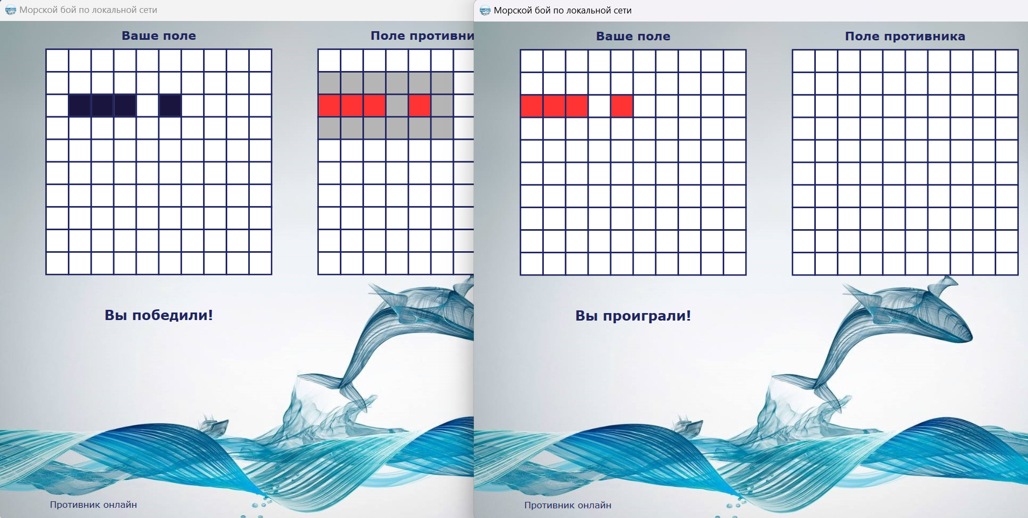
Рис.7. Окончание игры
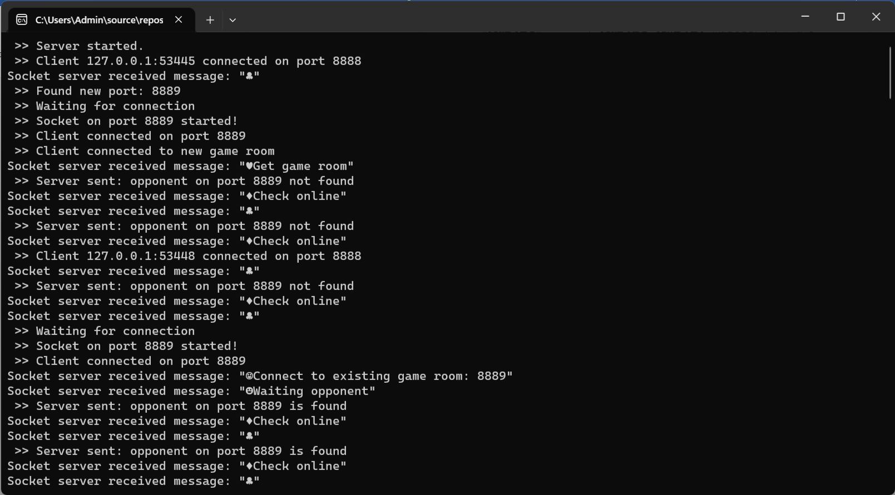
Рис.8. Обработка запросов сервером
2. Листинг программы
Библиотека GameRoom:
GameRoom.cs
using System.Net.Sockets;

public class GameRoom
{
private int _maxPlayers = 2;
public List<TcpClient> players;
public Port Port { get; set; }
public bool IsFirstPlayerSet;
public bool IsPlayerReady { get; set; }
public GameRoom(Port port)
{
players = new List<TcpClient>();
Port = port;
}
public void AddPlayer(TcpClient player)
{
players.Add(player ?? throw new ArgumentNullException(nameof(players)));
}
public void RemovePlayer(TcpClient player)
{
players.Remove(player ?? throw new ArgumentNullException(nameof(players)));
}
public bool IsFull()
{
return players.Count == _maxPlayers;
}
public bool IsEmpty()
{
return players.Count == 0;
}
public void SetFirstPlayer()
{
IsFirstPlayerSet = true;
}
}
GameRoomManager.cs
using System.Net.Sockets;

public class GameRoomManager
{
private List<GameRoom> _gameRooms;
public GameRoomManager()
{
_gameRooms = new List<GameRoom>();
}
public bool IsPlayerReady(Port port)
{
GameRoom room = FindGameRoom(port);
return room.IsPlayerReady;
}
public void SetPlayerReady(bool value, Port port)
{
GameRoom room = FindGameRoom(port);
room.IsPlayerReady = value;
}
public bool IsFirstPlayer(TcpClient client, Port port)
{
GameRoom room = FindGameRoom(port);
if (!room.IsFirstPlayerSet)
{
room.SetFirstPlayer();
return true;
}
return false;
}
public void AddPlayerToExistsRoom(TcpClient player, Port port)
{
GameRoom connectionRoom = GetConnectionRoom(port);
connectionRoom.AddPlayer(player);
}
public void AddPlayerToNewRoom(TcpClient player, Port port)
{
GameRoom newRoom = CreateGameRoom(port);
newRoom.AddPlayer(player);
}
public GameRoom GetConnectionRoom(Port port)
{
GameRoom connectionRoom = null;
foreach (GameRoom room in _gameRooms)
{
if (room.Port == port)
{
if (!room.IsFull())
{
if (!room.IsEmpty())
{
connectionRoom = room;
return connectionRoom;
}
else
throw new ArgumentException("Комната не найдена");
}
else
throw new ArgumentException("Комната уже занята");
}
}
throw new ArgumentException("Комната не найдена");
}
public void RemovePlayerFromGameRoom(Port port, TcpClient player)
{
GameRoom room = FindGameRoom(port);
if (room != null)
{
room.RemovePlayer(player);
if (room.IsEmpty())
RemoveGameRoom(room);
}
}
public GameRoom? FindGameRoom(Port port)
{
foreach (GameRoom room in _gameRooms)
{
if (room.Port == port)
{
return room;
}
}
return null;
}
public bool CheckPlayersConnection(Port port)
{
foreach(GameRoom room in _gameRooms)
{
if (room.Port == port)
{
return room.IsFull();
}
}
return false;
}
public TcpClient GetOpponent(TcpClient client, Port port)
{
foreach (GameRoom room in _gameRooms)
{
if (room.Port == port)
{
if (room.players[0] == client)
return room.players[1];
else return room.players[0];
}
}
return client;
}
private void RemoveGameRoom(GameRoom gameRoom)
{
_gameRooms.Remove(gameRoom);
}

private GameRoom CreateGameRoom(Port port)
{
GameRoom gameRoom = new GameRoom(port);
_gameRooms.Add(gameRoom);
return gameRoom;
}
}
Port.cs

public class Port
{
public int PortValue { get; }
public bool Occupied { get; set; }

public Port(int _portValue, bool _occupied)
{
PortValue = _portValue;
Occupied = _occupied;
}
}
Библиотека Request:
RequestParser.cs
using System;
using System.Collections.Generic;
using System.IO;
using System.Linq;
using System.Text;
using System.Threading.Tasks;

public class RequestParser
{
private byte _createNewGameRequest = 0;
private byte _connectToExistingGameRoom = 1;
private byte _waitingOpponent = 2;
private byte _getNewPortRequest = 3;
private byte _checkOnlineRequest = 4;
private byte _startGameRequest = 8;
private byte _checkCellRequest = 9;
private byte _opponentMoveRequest = 10;
private byte _sendCellState = 11;
private byte _reconnect = 12;

public string Parse(string request)
{
if (request == @"Create new game")
return Encoding.UTF8.GetString(new[] { _createNewGameRequest }) + request;
if (request == @"Get game room")
return Encoding.UTF8.GetString(new[] { _getNewPortRequest }) + request;
if(request.Contains("Connect to existing game room: "))
return Encoding.UTF8.GetString(new[] { _connectToExistingGameRoom }) + request;
if (request == @"Check online")
return Encoding.UTF8.GetString(new[] { _checkOnlineRequest }) + request;
if (request == @"Waiting opponent")
return Encoding.UTF8.GetString(new[] { _waitingOpponent }) + request;
if (request == @"Start game")
return Encoding.UTF8.GetString(new[] { _startGameRequest }) + request;
if (request.Contains("Hits cell:") )
return Encoding.UTF8.GetString(new[] { _checkCellRequest }) + request;
if (request == @"Wait opponent...")
return Encoding.UTF8.GetString(new[] { _opponentMoveRequest }) + request;
if (request.Contains("Cell state:"))
return Encoding.UTF8.GetString(new[] { _sendCellState }) + request;
if(request.Contains("Reconnect to port:"))
return Encoding.UTF8.GetString(new[] { _reconnect }) + request;
else
return null;

}
}

RequestType.cs

public enum RequestType : byte
{
CreateNewGame = 0,
JoinToGame = 1,
WaitingOpponent = 2,
Port = 3,
Online = 4,
Ping = 5,
Disconnect = 6,
Exception = 7,
StartGame = 8,
CheckOpponentCell = 9,
OpponentMove = 10,
CellState = 11,
Reconnect = 12
}

Проект BattleShipServer:
TCPServer.cs
using System;
using System.Net.Sockets;
using System.Net;
using System.Text;

namespace BattleShipServer;

public class TCPServer
{
private ILogger _logger;
private Port[] _ports;
private Port startPort;
private int portsAmount = 1000;
private GameRoomManager roomManager;

public TCPServer(ILogger logger)
{
_ports = new Port[1000];
startPort = new Port(8888, false);
_ports = new Port[1000];
_logger = logger ?? throw new ArgumentNullException(nameof(logger));
roomManager = new GameRoomManager();
InitializePorts();
}
public async Task Start()
{
TcpListener listener = new TcpListener(IPAddress.Any, startPort.PortValue);
listener.Start();

_logger.Log(" >> Server started.");
while (true)
{
TcpClient client = await listener.AcceptTcpClientAsync();

_logger.Log($" >> Client {client.Client?.RemoteEndPoint} connected on port {startPort.PortValue}");

ClientHandler clientHandler = new ClientHandler(client, _logger, startPort);
clientHandler.GetNewPortRequested += HandleCreateNewGameRoom;
clientHandler.GetExistingPortRequested += HandleJoinToExistingGameRoom;
clientHandler.DisconnectRequest += Disconnect;
clientHandler.ReconnectRequest += Reconnect;
clientHandler.Start();
}
}

private async Task<bool> Reconnect(int reconnectedPort, TcpClient client)
{
Port ConnectionPort = null;

foreach (Port port in _ports)
{
if (port.PortValue == reconnectedPort)
{
ConnectionPort = port;
break;
}
}

if (ConnectionPort == null)
{
_logger.Log($" >> Server sent: invalid room number");
return true;
}
else
{
ConnectionPort.Occupied = true;
TcpClient newClient = await RedirectingToNewPort(client, ConnectionPort, RequestType.Reconnect);
if (roomManager.FindGameRoom(ConnectionPort) == null)
roomManager.AddPlayerToNewRoom(newClient, ConnectionPort);
else
roomManager.AddPlayerToExistsRoom(newClient, ConnectionPort);
_logger.Log($" >> Client reconnecting on port {reconnectedPort}");
return false;
}
}
private async Task CreateNewGame(Port port, TcpClient client)
{
if (roomManager.CheckPlayersConnection(port))
{
await SendBoolMessage(client, true, RequestType.CreateNewGame);
TcpClient opponent = roomManager.GetOpponent(client, port);
if (opponent == client)
throw new Exception("Error");
await SendBoolMessage(opponent, true, RequestType.WaitingOpponent);
_logger.Log($" >> Start new game on port {port.PortValue}");
}
else
{
await SendBoolMessage(client, false, RequestType.CreateNewGame);
_logger.Log($" >> Error");
}
}

private async Task<TcpClient> RedirectingToNewPort(TcpClient client, Port newPort, RequestType type)
{

await SendNewPort(client, newPort, type);
_logger.Log($" >> Waiting for connection");

TcpClient cl = await WaitForConnection(newPort);
_logger.Log($" >> Client connected on port {newPort.PortValue}");

ClientHandler clientHandler = new ClientHandler(cl, _logger, newPort);
clientHandler.Start();
clientHandler.CheckOnline += CheckOnline;
//if(type == RequestType.Port)
clientHandler.CreateNewGameRequested += CreateNewGame;
clientHandler.DisconnectRequest += Disconnect;
clientHandler.StartGameRequested += HandleStartGame;
clientHandler.SendCoordinateToOpponentRequested += CheckPlayerReady;
clientHandler.SendCellStateToOpponentRequested += SendStateToOpponent;
clientHandler.SetReadinessRequested += SetReadiness;
return cl;
}

private async Task HandleCreateNewGameRoom(TcpClient client)
{
Port newPort = FindFreePort();
_logger.Log($" >> Found new port: {newPort.PortValue}");
TcpClient newClient = await RedirectingToNewPort(client, newPort, RequestType.Port);

roomManager.AddPlayerToNewRoom(newClient, newPort);
_logger.Log($" >> Client connected to new game room");

}
private async Task HandleStartGame(Port port, TcpClient client)
{
TcpClient opponent = roomManager.GetOpponent(client, port);
if (opponent == client)
throw new Exception("Error");
if (!roomManager.IsFirstPlayer(client, port))
{
await SendBoolMessage(client, false, RequestType.StartGame);
await SendBoolMessage(opponent, true, RequestType.StartGame);
}

_logger.Log($" >> Server sent: start game on port {port.PortValue}");
}

private async Task CheckOnline(Port port, TcpClient client)
{
bool opponentConnect = roomManager.CheckPlayersConnection(port);
await SendBoolMessage(client, opponentConnect, RequestType.Online);
if (opponentConnect)
_logger.Log($" >> Server sent: opponent on port {port.PortValue} is found");
else
_logger.Log($" >> Server sent: opponent on port {port.PortValue} not found");

}
private async Task<bool> HandleJoinToExistingGameRoom(TcpClient client, int portValue)
{
Port ConnectionPort = null;
foreach (Port port in _ports)
{
if (port.PortValue == portValue && port.Occupied == true)
{
ConnectionPort = port;
break;
}
}

if (ConnectionPort == null)
{
await SendStringMessage(client, "Такой комнаты не существует", RequestType.JoinToGame);
//await SendBoolMessage(client, false, RequestType.JoinToGame);
_logger.Log($" >> Server sent: invalid room number");
return true;
}
else
{
try
{
roomManager.GetConnectionRoom(ConnectionPort);
TcpClient newClient = await RedirectingToNewPort(client, ConnectionPort, RequestType.JoinToGame);
//await SendBoolMessage(newClient, true, RequestType.JoinToGame);
roomManager.AddPlayerToExistsRoom(newClient, ConnectionPort);
return false;
}
catch (Exception ex)
{
await SendStringMessage(client, ex.Message, RequestType.JoinToGame);
//await SendBoolMessage(client, false, RequestType.JoinToGame);
_logger.Log($" >> Server sent: invalid room number");
return true;
}
}
}
private void SetReadiness(Port port)
{
roomManager.SetPlayerReady(true, port);
_logger.Log($" >> Server sent: opponent on port {port.PortValue} ready");
}
private async Task CheckPlayerReady(Port port, TcpClient client, string message)
{
bool startFlag;
startFlag = roomManager.IsPlayerReady(port);
if (startFlag)
{
await SendCoordinateToOpponent(port, client, message);
}
else
{
await SendStringMessage(client, "Try again", RequestType.CheckOpponentCell);
_logger.Log($" >> Server sent: try again");
}
}
private async Task SendCoordinateToOpponent(Port port, TcpClient client, string message)
{
TcpClient opponent = roomManager.GetOpponent(client, port);
if (opponent == client)
throw new Exception("Error");
await SendStringMessage(opponent, message, RequestType.OpponentMove);

_logger.Log($" >> Server sent coordinate on port {port.PortValue}: {message}");
}
private async Task SendStateToOpponent(Port port, TcpClient client, string message)
{
roomManager.SetPlayerReady(false, port);
TcpClient opponent = roomManager.GetOpponent(client, port);
if (opponent == client)
throw new Exception("Error");
await SendStringMessage(opponent, message, RequestType.CheckOpponentCell);
_logger.Log($" >> Server sent cell state on port {port.PortValue}: {message}");
}
private async Task SendStringMessage(TcpClient client, string value, RequestType type)
{
byte[] bytes = Encoding.UTF8.GetBytes($"{value}"),
responseBytes = new byte[bytes.Length + 1];
await SendMessage(bytes, responseBytes, client, type);
}
private async Task SendBoolMessage(TcpClient client, bool value, RequestType type)
{
byte[] bytes = BitConverter.GetBytes(value);
byte[] responseBytes = new byte[bytes.Length + 1];
await SendMessage(bytes, responseBytes, client, type);
}

private async Task SendNewPort(TcpClient client, Port port, RequestType type)
{
byte[] bytes = Encoding.UTF8.GetBytes($"{port.PortValue}"),
responseBytes = new byte[bytes.Length + 1];

await SendMessage(bytes, responseBytes, client, type);
await Disconnect(null, client);
}
private async Task SendMessage(byte[] bytes, byte[] responseBytes, TcpClient client, RequestType type)
{
NetworkStream networkStream = client.GetStream();
responseBytes[0] = (byte)type;
Array.Copy(bytes, 0, responseBytes, 1, bytes.Length);

await networkStream.WriteAsync(responseBytes, 0, responseBytes.Length);
await networkStream.FlushAsync();
}
private async Task<TcpClient> WaitForConnection(Port port)
{
TcpListener listener = new TcpListener(IPAddress.Any, port.PortValue);
listener.Start();

TcpClient client = await listener.AcceptTcpClientAsync();
listener.Stop();

_logger.Log($" >> Socket on port {port.PortValue} started!");
return client;
}
private Port FindFreePort()
{
foreach (Port port in _ports)
if (port.Occupied == false)
{
port.Occupied = true;
return port;
}
throw new ApplicationException("There is no free port.");
}
private void InitializePorts()
{
for (int i = 0; i < portsAmount; i++)
_ports[i] = new Port(startPort.PortValue + 1 + i, false);
}
private async Task Disconnect(Port? port, TcpClient client)
{
client.Close();
client.Dispose();
if (port != null)
{
if (roomManager.FindGameRoom(port) != null)
{
roomManager.RemovePlayerFromGameRoom(port, client);
_logger.Log($" >> Disconnect client on port {port.PortValue}");
TcpClient opponent = roomManager.GetOpponent(client, port);
if (opponent != client)
{
await SendBoolMessage(opponent, false, RequestType.Online);
_logger.Log($" >> Server sent: opponent on port {port.PortValue} disconnected");
}
else
{
port.Occupied = false;
_logger.Log($" >> Server sent: port {port.PortValue} is released");
}
}
else
{
_logger.Log(" >> Client disconnected");
}
}
}
}
ClientHandler.cs
using System.Net.Sockets;
using System.Text;
using System.Text.RegularExpressions;

namespace BattleShipServer;

public class ClientHandler : IDisposable
{
private TcpClient client;
private ILogger logger;
public Port port;
private NetworkStream networkStream;
private Thread thread;
private bool _isActiv;

public event Func<TcpClient, int, Task<bool>> GetExistingPortRequested;
public event Func<TcpClient, Task> GetNewPortRequested;
public event Func<Port, TcpClient, Task> StartGameRequested;
public event Func<Port, TcpClient, Task> CheckOnline;
public event Func<Port, TcpClient, Task> CreateNewGameRequested;
public event Func<Port, TcpClient, Task> DisconnectRequest;
public event Func<Port, TcpClient, string, Task> SendCoordinateToOpponentRequested;
public event Func<Port, TcpClient, string, Task> SendCellStateToOpponentRequested;
public event Func<int, TcpClient, Task<bool>> ReconnectRequest;
public event Action<Port> SetReadinessRequested;

public ClientHandler(TcpClient client, ILogger logger, Port _port)
{
if (client == null)
throw new ArgumentNullException(nameof(client));
port = _port;
this.client = client;
networkStream = this.client.GetStream();
this.logger = logger;
}
public void Start()
{
_isActiv = true;
thread = new Thread(Listen);
thread.Start();
}
private async void Listen()
{
try
{
while (_isActiv)
{
byte[] buffer = new byte[1024 * 8];
StringBuilder request = new StringBuilder();

await GetRequest(buffer, request);
await SendResponse(request.ToString());

logger.Log($"Socket server received message: \"{request}\"");
}
}
catch
{
Disconnect();
}
}
private async Task GetRequest(byte[] buffer, StringBuilder request)
{
CheckConneciton();
int bytesRead = await networkStream.ReadAsync(buffer);

while (bytesRead > 0)
{
request.Append(Encoding.UTF8.GetString(buffer, 0, bytesRead));

if (networkStream.DataAvailable == false)
break;

bytesRead = await networkStream.ReadAsync(buffer, 0, buffer.Length);
}
}
private async Task SendResponse(string request)
{
byte[] type = Encoding.UTF8.GetBytes(request.Substring(0, 1));
request = request.Substring(1, request.Length - 1);
try
{
switch ((RequestType)type[0])
{
case RequestType.CreateNewGame:
await CreateNewGame();
break;
case RequestType.JoinToGame:
//проверить создана ли игровая комната в переданном порту и количество человек в ней
_isActiv = false;
await JoinToExistingGameRoom(GetPortFromRequest(request));
break;
case RequestType.Port:
//отправить номер порта
await CreateNewGameRoom();
_isActiv = false;
break;
case RequestType.Online:
await CheckOpponentOnline();
break;
case RequestType.WaitingOpponent:
break;
case RequestType.Ping:
break;
case RequestType.Disconnect:
_isActiv = false;
Disconnect();
break;
case RequestType.StartGame:
await StartGame();
break;
case RequestType.CheckOpponentCell:
await SendCoordinateMessage(request);
break;
case RequestType.CellState:
await SendStateMessage(request);
break;
case RequestType.OpponentMove:
SetReadiness();
break;
case RequestType.Reconnect:
await Reconnect(GetPortFromRequest(request));
break;
default:
throw new ApplicationException("Wrong signature!");
}
}
catch (Exception ex)
{
await SendStringAsync(ex.Message, RequestType.Exception);
}
}
private async Task Reconnect(string portValue)
{
int ConnectionPortValue = 0;
if (int.TryParse(portValue, out int number))
ConnectionPortValue = number;
else
throw new ArgumentException(nameof(portValue));

if (ConnectionPortValue != 0)
{
if (ReconnectRequest != null)
_isActiv = await ReconnectRequest.Invoke(ConnectionPortValue, client);
else
throw new ArgumentNullException(nameof(ReconnectRequest));
}
else
throw new ArgumentException();
}
private void SetReadiness()
{
if (SetReadinessRequested != null)
SetReadinessRequested.Invoke(port);
else
throw new ArgumentNullException(nameof(SetReadinessRequested));
}
private async Task SendStateMessage(string request)
{
if (SendCellStateToOpponentRequested != null)
await SendCellStateToOpponentRequested.Invoke(port, client, request);
else
throw new ArgumentNullException(nameof(SendCellStateToOpponentRequested));
}
private async Task SendCoordinateMessage(string request)
{
if (SendCoordinateToOpponentRequested != null)
await SendCoordinateToOpponentRequested.Invoke(port, client, request);

else
throw new ArgumentNullException(nameof(SendCoordinateToOpponentRequested));
}
private async Task StartGame()
{
if (StartGameRequested != null)
await StartGameRequested.Invoke(port, client);
else
throw new ArgumentNullException(nameof(StartGameRequested));
}
private async Task CreateNewGame()
{
if (CreateNewGameRequested != null)
await CreateNewGameRequested.Invoke(port, client);
else
throw new ArgumentNullException(nameof(CreateNewGameRequested));
}
private async Task CheckOpponentOnline()
{
if (CheckOnline != null)
await CheckOnline.Invoke(port, client);
else
throw new ArgumentNullException(nameof(CheckOnline));
}
private string GetPortFromRequest(string request)
{
string result = Regex.Replace(request, @"[^\d]", "");
return result;
}
private void Disconnect()
{
if (DisconnectRequest != null)
DisconnectRequest.Invoke(port, client);
else
throw new ArgumentNullException(nameof(DisconnectRequest));
}
private async Task CreateNewGameRoom()
{
if (GetNewPortRequested != null)
await GetNewPortRequested.Invoke(client);
else
throw new ArgumentNullException(nameof(GetNewPortRequested));
}
private async Task JoinToExistingGameRoom(string PortValue)
{
int ConnectionPortValue = 0;
if (int.TryParse(PortValue, out int number))
ConnectionPortValue = number;
else
throw new ArgumentException(nameof(PortValue));

if (ConnectionPortValue != 0)
{
if (GetExistingPortRequested != null)
_isActiv = await GetExistingPortRequested.Invoke(client, ConnectionPortValue);
else
throw new ArgumentNullException(nameof(GetExistingPortRequested));
}
else
throw new ArgumentException();
}

private async Task SendStringAsync(string response, RequestType type)
{
byte[] bytes = Encoding.UTF8.GetBytes(response);
byte[] responseBytes = new byte[bytes.Length + 1];
logger.Log($"Server sent: {response}");
responseBytes[0] = (byte)type;
Array.Copy(bytes, 0, responseBytes, 1, bytes.Length);

await networkStream.WriteAsync(responseBytes, 0, responseBytes.Length);
await networkStream.FlushAsync();
}
private void CheckConneciton()
{
if (client.Connected == false)
Disconnect();
}
public void Dispose()
{
Disconnect();
}
}

Проект BattleShip:
GameRoomManager.cs

using System;
using System.Collections.Generic;
using System.Data.Common;
using System.Linq;
using System.Text.RegularExpressions;
using System.Threading;
using System.Threading.Tasks;

namespace BattleShip.Model;
public enum HitState
{
Kill,
Hit,
Miss
}
public class GameManager
{
private List<Cell> _playerCells;
private List<Cell> _enemyCells;
private List<Ship> _availableShips;
private Cell _cell;
private Player _player;
private RequestParser _requestParser;
private string _lastRequest;
private bool _requestSuccess;
public int PlayerScore;
public int OpponentScore;
public int MaxNumberOfPoints;

public event Action LastRequestChanged;
public event Action RequestSuccessedChanged;
public event Action PlayerCellsChanged;
public event Action EnemyCellsChanged;
public event Action AvailableShipsChanged;
public delegate void CellUpdatedEventHandler(Cell cell);
public event CellUpdatedEventHandler CellUpdated;
public delegate void EnemyCellUpdatedEventHandler(Cell cell);
public event EnemyCellUpdatedEventHandler EnemyCellUpdated;
public delegate void AvailableShipsUpdatedEventHandler(Ship ship);

private string _hitsCellRequest = "Hits cell:";
private string _waitCellForCheckRequest = "Wait opponent...";
private string _cellStateRequest = "Cell state:";

public GameManager(Player player)
{
// Инициализация списка клеток игрока
_requestParser = new RequestParser();
_player = player;
PlayerCells = GenerateCells();
AvailableShips = GenerateShips();
MaxNumberOfPoints = AvailableShips.Count;
}

private List<Ship> GenerateShips()
{
var AvailableShips = new List<Ship>
{
new Ship(3),
new Ship(1)
//new Ship(1),
//new Ship(1),
//new Ship(1),
//new Ship(2),
//new Ship(2),
//new Ship(2),
//new Ship(3),
//new Ship(3),
//new Ship(4)
};
return AvailableShips;
}
public void GenerateEnemyField()
{
EnemyCells = GenerateCells();
}

private List<Cell> GenerateCells()
{
var cells = new List<Cell>();

for (int i = 0; i < 10; i++)
{
for (int j = 0; j < 10; j++)
{
var cell = new Cell(i, j);
cells.Add(cell);
}
}

return cells;
}
public List<Ship> AvailableShips
{
get { return _availableShips; }
set
{
_availableShips = value;
OnAvailableShipsChanged();
}
}
public string LastRequest
{
get { return _lastRequest; }
set
{
_lastRequest = value;
OnLastRequestChanged();
}
}
public bool RequestSuccess
{
get { return _requestSuccess; }
set
{
_requestSuccess = value;
OnRequestSuccessedChanged();
}
}

public List<Cell> PlayerCells
{
get { return _playerCells; }
set
{
_playerCells = value;
OnPlayerCellsChanged();
}
}
public List<Cell> EnemyCells
{
get { return _enemyCells; }
set
{
_enemyCells = value;
OnEnemyCellsChanged();
}
}
public Cell Cell
{
get { return _cell; }
set
{
_cell = value;
UpdateCell(_cell);
}
}
protected virtual void OnLastRequestChanged()
{
LastRequestChanged?.Invoke();
}
protected virtual void OnRequestSuccessedChanged()
{
RequestSuccessedChanged?.Invoke();
}
protected virtual void OnPlayerCellsChanged()
{
PlayerCellsChanged?.Invoke();
}
protected virtual void OnEnemyCellsChanged()
{
EnemyCellsChanged?.Invoke();
}
protected virtual void OnAvailableShipsChanged()
{
AvailableShipsChanged?.Invoke();
}

private void UpdateCell(Cell cell)
{
CellUpdated?.Invoke(cell);
}
private void UpdateEnemyCell(Cell cell)
{
EnemyCellUpdated?.Invoke(cell);
}

public void AddShipToCells(int row, int column, Ship ship, ShipDirection direction)
{
Cell cell = _playerCells.FirstOrDefault(c => c.Row == row && c.Column == column);
int shipSize = ship.Size;

if (!CanPlaceShip(cell, shipSize, direction))
throw new Exception("Здесь нельзя разместить корабль данного типа!");

PlaceShip(cell, shipSize, direction);
AvailableShips.Remove(ship);
OnAvailableShipsChanged();
}

private bool CanPlaceShip(Cell startCell, int shipSize, ShipDirection direction)
{
int row = startCell.Row;
int column = startCell.Column;

if (shipSize == 1)
{
if (!CheckRightAndLeftBorders(row, column, shipSize) ||
!CheckUpperAndLowerBorders(row, column, shipSize))
return false;
}
else if (direction == ShipDirection.Horizontal)
{
if (CheckRightAndLeftBorders(row, column, shipSize))
for (int i = 0; i < shipSize; i++)
{
Cell cell = FindCell(row, column + i, "Player");
if (!CheckCell(cell, CellState.Empty) || !CheckLowerAndUpperCell(cell, CellState.Empty, "Player"))
return false;
}
else
return false;
}
else if (direction == ShipDirection.Vertical)
{
if (CheckUpperAndLowerBorders(row, column, shipSize))
for (int i = 0; i < shipSize; i++)
{
Cell cell = FindCell(row + i, column, "Player");
if (!CheckCell(cell, CellState.Empty) || !CheckRightAndLeftCell(cell, CellState.Empty, "Player"))
return false;
}
else
return false;
}
return true;
}
private bool CheckRightAndLeftBorders(int row, int column, int shipSize)
{
if (column + shipSize > 10)
return false;

Cell leftCell = FindCell(row, column - 1, "Player");
if (!CheckCell(leftCell, CellState.Empty))
return false;
else if (!CheckLowerAndUpperCell(leftCell, CellState.Empty, "Player"))
return false;

Cell rightCell = FindCell(row, column + shipSize, "Player");
if (!CheckCell(leftCell, CellState.Empty))
return false;
else if (!CheckLowerAndUpperCell(rightCell, CellState.Empty, "Player"))
return false;
return true;
}

private bool CheckUpperAndLowerBorders(int row, int column, int shipSize)
{
if (row + shipSize > 10)
return false;

Cell lowerCell = FindCell(row - 1, column, "Player");
if (!CheckCell(lowerCell, CellState.Empty))
return false;
else if (!CheckRightAndLeftCell(lowerCell, CellState.Empty, "Player"))
return false;

Cell rightCell = FindCell(row + shipSize, column, "Player");
if (!CheckCell(rightCell, CellState.Empty))
return false;
else if (!CheckRightAndLeftCell(rightCell, CellState.Empty, "Player"))
return false;
return true;
}
private bool CheckLowerAndUpperCell(Cell cell, CellState state, string field)
{
if(state == CellState.Empty)
{
if (cell == null)
return true;
if (CheckCell(FindCell(cell.Row + 1, cell.Column, field), state) &&
CheckCell(FindCell(cell.Row - 1, cell.Column, field), state))
return true;
}
else if (state == CellState.Ship || state == CellState.Hit)
{
if (CheckCell(FindCell(cell.Row + 1, cell.Column, field), state) ||
CheckCell(FindCell(cell.Row - 1, cell.Column, field), state))
return true;
}
return false;

}
private bool CheckRightAndLeftCell(Cell cell, CellState state, string field)
{
if(state == CellState.Empty)
{
if (cell == null)
return true;
if (CheckCell(FindCell(cell.Row, cell.Column + 1, field), state) &&
CheckCell(FindCell(cell.Row, cell.Column - 1, field), state))
return true;
}
else if (state == CellState.Ship || state == CellState.Hit)
{
if (CheckCell(FindCell(cell.Row, cell.Column + 1, field), state) ||
CheckCell(FindCell(cell.Row, cell.Column - 1, field), state))
return true;
}
return false;
}

private bool CheckCell(Cell cell, CellState state)
{
if (state == CellState.Empty)
{
if (cell == null || cell.State == CellState.Empty)
return true;
}
else if (state == CellState.Ship)
{
if (cell != null && cell.State == CellState.Ship)
return true;
}
else if (state == CellState.Hit)
{
if (cell != null && (cell.State == CellState.Ship || cell.State == CellState.Hit))
return true;
}
else if (state == CellState.Miss)
{
if (cell != null)
return true;
}
return false;

}
private Cell FindCell(int row, int col, string field)
{
Cell cell;
bool cellExists = true;
if (row < 0 || col < 0)
cellExists = false;
if (cellExists == false)
return null;
if(field == "Player")
cell = PlayerCells.FirstOrDefault(c => c.Row == row && c.Column == col);
else
cell = EnemyCells.FirstOrDefault(c => c.Row == row && c.Column == col);
return cell;
}
private void PlaceShip(Cell startCell, int shipSize, ShipDirection direction)
{
int row = startCell.Row;
int column = startCell.Column;

if (direction == ShipDirection.Horizontal)
{
for (int i = 0; i < shipSize; i++)
{
var cell = PlayerCells.FirstOrDefault(c => c.Row == row && c.Column == column + i);
cell.State = CellState.Ship;
UpdateCell(cell);
}
}
else
{
for (int i = 0; i < shipSize; i++)
{
var cell = PlayerCells.FirstOrDefault(c => c.Row == row + i && c.Column == column);
cell.State = CellState.Ship;
UpdateCell(cell);
}
}
}

public void DeleteShipFromCells(int row, int column)
{
Cell cell = _playerCells.FirstOrDefault(c => c.Row == row && c.Column == column);
ShipDirection shipDirection = DeterminingDirection(cell, CellState.Ship, "Player");
Cell firstCell = FindFirstCell(cell, shipDirection, CellState.Ship, "Player");
int shipSize = DeterminingShipSize(firstCell, shipDirection, CellState.Ship);
Ship ship = new Ship(shipSize);
// Разместить корабль на игровом поле
DeleteShip(firstCell, shipSize, shipDirection);
AvailableShips.Add(ship);
OnAvailableShipsChanged();
}

private void DeleteShip(Cell startCell, int shipSize, ShipDirection direction)
{
int row = startCell.Row;
int column = startCell.Column;

if (direction == ShipDirection.Horizontal)
{
for (int i = 0; i < shipSize; i++)
{
var cell = PlayerCells.FirstOrDefault(c => c.Row == row && c.Column == column + i);
cell.State = CellState.Empty;
UpdateCell(cell);
}
}
else
{
for (int i = 0; i < shipSize; i++)
{
var cell = PlayerCells.FirstOrDefault(c => c.Row == row + i && c.Column == column);
cell.State = CellState.Empty;
UpdateCell(cell);
}
}
}

private Cell FindFirstCell(Cell cell, ShipDirection shipDirection, CellState state, string field)
{
Cell firstCell = new Cell(cell.Row, cell.Column);
firstCell.State = state;
if (shipDirection == ShipDirection.Horizontal)
{
for (int i = 1; i < 4; i++)
{
if (CheckCell(FindCell(cell.Row, cell.Column - i, field), state))
firstCell = FindCell(cell.Row, cell.Column - i, field);
else break;
}
}
else
{
for (int i = 1; i < 4; i++)
{
if (CheckCell(FindCell(cell.Row - i, cell.Column, field), state))
firstCell = FindCell(cell.Row - i, cell.Column, field);
else break;
}
}
return firstCell;
}

private int DeterminingShipSize(Cell startCell, ShipDirection direction, CellState state)
{
int shipSize = 0;
string field = "Player";
if (direction == ShipDirection.Horizontal)
{
for (int i = 0; i < 4; i++)
{
if (CheckCell(FindCell(startCell.Row, startCell.Column + i, field), state))
{
shipSize++;
if (state == CellState.Hit)
if(FindCell(startCell.Row, startCell.Column + i, field).State == CellState.Hit)
shipSize--;
}

else break;
}
}
else
{
for (int i = 0; i < 4; i++)
{
if (CheckCell(FindCell(startCell.Row + i, startCell.Column, field), state))
{
shipSize++;
if (state == CellState.Hit)
if (FindCell(startCell.Row + i, startCell.Column, field).State == CellState.Hit)
shipSize--;
}
else break;
}
}
return shipSize;
}

private ShipDirection DeterminingDirection(Cell startCell, CellState state, string field)
{
if (!CheckLowerAndUpperCell(startCell, state, field))
if (CheckRightAndLeftCell(startCell, state, field))
return ShipDirection.Horizontal;
return ShipDirection.Vertical;
}

private int DeterminingKilledShipSize(Cell cell, ShipDirection direction)
{
int firstRow = cell.Row;
int firstColumn = cell.Column;
Cell newCell = cell;
int shipSize = 1;
bool flag = true;
if (direction == ShipDirection.Horizontal)
{
int j = firstColumn;
while (flag)
{
newCell = FindCell(firstRow, j + 1, "Enemy");
if (CheckCell(newCell, CellState.Hit))
{
shipSize++;
j++;
}
else
flag = false;
}
}
else if(direction == ShipDirection.Vertical)
{
int j = firstRow;
while (flag)
{
newCell = FindCell(j + 1, firstColumn, "Enemy");
if (CheckCell(newCell, CellState.Hit))
{
shipSize++;
j++;
}
else
flag = false;
}
}
return shipSize;
}
private List<Cell> cellsAround = new List<Cell>();
private bool IsUpperBorderExist = true;
private bool IsLowerBorderExist = true;
private bool IsRightBorderExist = true;
private bool IsLeftBorderExist = true;

private void CheckLeftAndRightKilledShipBorders(Cell cell, int shipSize)
{
int firstRow = cell.Row;
int firstColumn = cell.Column;
Cell leftCell = FindCell(firstRow, firstColumn - 1, "Enemy");
Cell rightCell = FindCell(firstRow, firstColumn + shipSize, "Enemy");
if (CheckCell(leftCell, CellState.Miss))
{
cellsAround.Add(leftCell);
CheckIsUpperBorderExist(leftCell);
CheckIsLowerBorderExist(leftCell);
if (CheckCell(rightCell, CellState.Miss))
{
cellsAround.Add(rightCell);
CheckIsUpperBorderExist(rightCell);
CheckIsLowerBorderExist(rightCell);
}
}
else
{
cellsAround.Add(rightCell);
CheckIsUpperBorderExist(rightCell);
CheckIsLowerBorderExist(rightCell);
}
}
private void CheckUpperAndLowerBorders(Cell cell, int shipSize)
{
int firstRow = cell.Row;
int firstColumn = cell.Column;
Cell upperCell = FindCell(firstRow - 1, firstColumn, "Enemy");
Cell lowerCell = FindCell(firstRow + shipSize, firstColumn, "Enemy");
if (CheckCell(upperCell, CellState.Miss))
{
cellsAround.Add(upperCell);
CheckIsRightBorderExist(upperCell);
CheckIsLeftBorderExist(upperCell);
if (CheckCell(lowerCell, CellState.Miss))
{
cellsAround.Add(lowerCell);
CheckIsRightBorderExist(lowerCell);
CheckIsLeftBorderExist(lowerCell);
}
}
else
{
cellsAround.Add(lowerCell);
CheckIsRightBorderExist(lowerCell);
CheckIsLeftBorderExist(lowerCell);
}
}
private void CheckIsRightBorderExist(Cell cell)
{
int firstRow = cell.Row;
int firstColumn = cell.Column;
Cell newCell = FindCell(firstRow, firstColumn + 1, "Enemy");
IsRightBorderExist = CheckCell(newCell, CellState.Miss);
if (IsRightBorderExist)
cellsAround.Add(newCell);
}
private void CheckIsLeftBorderExist(Cell cell)
{
int firstRow = cell.Row;
int firstColumn = cell.Column;
Cell newCell = FindCell(firstRow, firstColumn - 1, "Enemy");
IsLeftBorderExist = CheckCell(newCell, CellState.Miss);
if (IsLeftBorderExist)
cellsAround.Add(newCell);
}
private void CheckIsUpperBorderExist(Cell cell)
{
int firstRow = cell.Row;
int firstColumn = cell.Column;
Cell newCell = FindCell(firstRow - 1, firstColumn, "Enemy");
IsUpperBorderExist = CheckCell(newCell, CellState.Miss);
if (IsUpperBorderExist)
cellsAround.Add(newCell);
}
private void CheckIsLowerBorderExist(Cell cell)
{
int firstRow = cell.Row;
int firstColumn = cell.Column;
Cell newCell = FindCell(firstRow + 1, firstColumn, "Enemy");
IsLowerBorderExist = CheckCell(newCell, CellState.Miss);
if (IsLowerBorderExist)
cellsAround.Add(newCell);
}
private void DeterminingLowerBorderCells(int firstRow, int firstColumn, int shipSize)
{
for (int i = 0; i < shipSize; i++)
{
Cell newCell = FindCell(firstRow + 1, firstColumn + i, "Enemy");
cellsAround.Add(newCell);
}
}
private void DeterminingUpperBorderCells(int firstRow, int firstColumn, int shipSize)
{
for (int i = 0; i < shipSize; i++)
{
Cell newCell = FindCell(firstRow - 1, firstColumn + i, "Enemy");
cellsAround.Add(newCell);
}
}
private void DeterminingLeftBorderCells(int firstRow, int firstColumn, int shipSize)
{
for (int i = 0; i < shipSize; i++)
{
Cell newCell = FindCell(firstRow + i, firstColumn - 1, "Enemy");
cellsAround.Add(newCell);
}
}
private void DeterminingRightBorderCells(int firstRow, int firstColumn, int shipSize)
{
for (int i = 0; i < shipSize; i++)
{
Cell newCell = FindCell(firstRow + i, firstColumn + 1, "Enemy");
cellsAround.Add(newCell);
}
}
private void MakeAroundCellsStatesMiss(Cell firstCell, ShipDirection direction)
{
int firstRow = firstCell.Row;
int firstColumn = firstCell.Column;

int shipSize = DeterminingKilledShipSize(firstCell, direction);
if (shipSize == 1)
{
CheckLeftAndRightKilledShipBorders(firstCell, shipSize);
CheckUpperAndLowerBorders(firstCell, shipSize);
}
else if (direction == ShipDirection.Horizontal)
{
CheckLeftAndRightKilledShipBorders(firstCell, shipSize);
if (IsUpperBorderExist == false)
DeterminingLowerBorderCells(firstRow, firstColumn, shipSize);
else if (IsLowerBorderExist == false)
DeterminingUpperBorderCells(firstRow, firstColumn, shipSize);
else if (IsUpperBorderExist == true && IsLowerBorderExist == true)
{
DeterminingLowerBorderCells(firstRow, firstColumn, shipSize);
DeterminingUpperBorderCells(firstRow, firstColumn, shipSize);
}
}
else if (direction == ShipDirection.Vertical)
{
CheckUpperAndLowerBorders(firstCell, shipSize);
if (IsRightBorderExist == false)
DeterminingLeftBorderCells(firstRow, firstColumn, shipSize);
else if (IsLeftBorderExist == false)
DeterminingRightBorderCells(firstRow, firstColumn, shipSize);
else if (IsRightBorderExist == true && IsLeftBorderExist == true)
{
DeterminingLeftBorderCells(firstRow, firstColumn, shipSize);
DeterminingRightBorderCells(firstRow, firstColumn, shipSize);
}
}
foreach(Cell cell in cellsAround)
{
cell.State = CellState.Miss;
UpdateEnemyCell(cell);
}
}
public async Task<HitState> HitCell(int row, int column)
{
_player.StopCheckingOpponent();
string BadResponse = "Try again";
Cell cell = _enemyCells.FirstOrDefault(c => c.Row == row && c.Column == column);
LastRequest = _hitsCellRequest + $"row:{row} " + $"column:{column}";
RequestSuccess = false;
Response response = await _player.SendRequestWithResponseAsync(_requestParser.Parse(_hitsCellRequest + $"row:{row} " + $"column:{column}"));
RequestSuccess = true;
BadResponse = response.Contents;
int counter = 0;
while (counter != 5 && BadResponse.Contains("Try again"))
{
LastRequest = _hitsCellRequest + $"row:{row} " + $"column:{column}";
RequestSuccess = false;
response = await _player.SendRequestWithResponseAsync(_requestParser.Parse(_hitsCellRequest + $"row:{row} " + $"column:{column}"));
counter++;
BadResponse = response.Contents;
RequestSuccess = true;
}
HitState state = GetCellStateFromResponse(response.Contents);
if (state == HitState.Kill)
{
cell.State = CellState.Hit;
PlayerScore++;
ShipDirection shipDirection = DeterminingDirection(cell, CellState.Hit, "Enemy");
Cell firstCell = FindFirstCell(cell, shipDirection, CellState.Hit, "Enemy");

MakeAroundCellsStatesMiss(firstCell, shipDirection);
}
else if (state == HitState.Hit)
cell.State = CellState.Hit;
else if (state == HitState.Miss)
cell.State = CellState.Miss;
UpdateEnemyCell(cell);
return state;
}

public async Task<bool> IsOpponentMove()
{
LastRequest = _waitCellForCheckRequest;
RequestSuccess = false;
Response response = await _player.SendRequestWithResponseAsync(_requestParser.Parse(_waitCellForCheckRequest));
RequestSuccess = true;
if (GetCellFromResponse(response.Contents) != null)
{
Cell checkedCell = GetCellFromResponse(response.Contents);
if (checkedCell.State == CellState.Ship)
{
checkedCell.State = CellState.Hit;
ShipDirection shipDirection = DeterminingDirection(checkedCell, CellState.Hit, "Player");
Cell firstCell = FindFirstCell(checkedCell, shipDirection, CellState.Hit, "Player");
int shipSize = DeterminingShipSize(firstCell, shipDirection, CellState.Hit);
if (shipSize == 0)
{
LastRequest = _cellStateRequest + HitState.Kill.ToString();
RequestSuccess = false;
await _player.SendRequestAsync(_requestParser.Parse(_cellStateRequest + HitState.Kill.ToString()));
RequestSuccess = true;
OpponentScore++;
if(OpponentScore == MaxNumberOfPoints)
{
UpdateCell(checkedCell);
return true;
}
}
else
{
LastRequest = _cellStateRequest + HitState.Hit.ToString();
RequestSuccess = false;
await _player.SendRequestAsync(_requestParser.Parse(_cellStateRequest + HitState.Hit.ToString()));
RequestSuccess = true;
}

}
else if (checkedCell.State == CellState.Empty)
{
checkedCell.State = CellState.Miss;
UpdateCell(checkedCell);
LastRequest = _cellStateRequest + HitState.Miss.ToString();
RequestSuccess = false;
await _player.SendRequestAsync(_requestParser.Parse(_cellStateRequest + HitState.Miss.ToString()));
RequestSuccess = true;
return true;
}
UpdateCell(checkedCell);
}
return false;
}

private Cell GetCellFromResponse(string response)
{
// Паттерн регулярного выражения для извлечения значения row и column
string pattern = @"row:\s*(\d+)\s*column:\s*(\d+)";

// Поиск совпадений в строке response
Match match = Regex.Match(response, pattern);

if (match.Success)
{
// Получение значений row и column из совпадений
int row = int.Parse(match.Groups[1].Value);
int column = int.Parse(match.Groups[2].Value);
Cell cell = _playerCells.FirstOrDefault(c => c.Row == row && c.Column == column);
return cell;
}
else
{
return null;
}
}

private HitState GetCellStateFromResponse(string response)
{
// Проверка наличия подстроки "Cell state: " в ответе
if (response.Contains("Cell state:"))
{
// Получение значения CellState
string cellStateString = response.Substring(response.IndexOf("Cell state: ") + 12).Trim();

// Преобразование значения CellState в соответствующий перечислитель
switch (cellStateString.ToLower())
{
case "kill":
return HitState.Kill;
case "hit":
return HitState.Hit;
case "miss":
return HitState.Miss;
default:
throw new ArgumentException("Invalid cell state");
}
}
else
{
throw new ArgumentException("Invalid response format");
}
}
}

